**DEPARTMENT OF COMPUTER SCIENCE AND ENGINEERING**

**GOVERNMENT ENGINEERING COLLEGE, HASSAN**

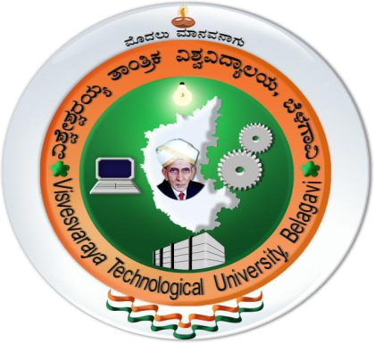**2019-2020**

**CERTIFICATE**

This is to certify that Ms.Aishwarya Jain USN:4GH117CS003, Mr.Gowtham H M USN: 4GH17CS016 and Ms.Impana Gowda USN: 4GH17CS018 has satisfactorily implemented the mini project titled “CLUB’S MANAGEMENT SYSTEM” in fifth semester DBMS Laboratory with mini project (15CSL58) as per the requirements of Visvesvaraya Technological University, Belagavi for the academic year 2019-2020.

**Mr.Annaiah H,B.E.,M.Tech,MISTE Ms.Priyanka H L,B.E.,M.Tech**

Assistant Professor Assistant Professor

Dept. of CS&E. Dept. of CS&E.

**External viva**

**Name of the Examiners Signature with date**

**1.**

**2.**